**NAME: KM MINAKSHI**

**COURSE: MCA2C**

**S.ID: 20712152 ROLL_NO: 2001077**

**JAVA END TERM PRACTICAL**

1. **Write a java program for Client Server communication using UDP Datagram Socket Programming**

import java.io.*;

import java.net.*;

public class udp_server

{

public static void main(String args[])

{

DatagramSocket sock = null;

try

{

//1. creating a server socket, parameter is local port number

sock = new DatagramSocket(7777);

//buffer to receive incoming data

byte[] buffer = new byte[65536];

DatagramPacket incoming = new DatagramPacket(buffer, buffer.length);

//2. Wait for an incoming data

echo("Server socket created. Waiting for incoming data...");

//communication loop

while(true)

{

sock.receive(incoming);

byte[] data = incoming.getData();

String s = new String(data, 0, incoming.getLength());

//echo the details of incoming data - client ip : client port - client message

echo(incoming.getAddress().getHostAddress() + " : " + incoming.getPort() + " - " + s);

s = "OK : " + s;

DatagramPacket dp = new DatagramPacket(s.getBytes() , s.getBytes().length , incoming.getAddress() , incoming.getPort());

sock.send(dp);

}

}

catch(IOException e)

{

System.err.println("IOException " + e);

}

}

//simple function to echo data to terminal

public static void echo(String msg)

{

System.out.println(msg);

}

}

Output:

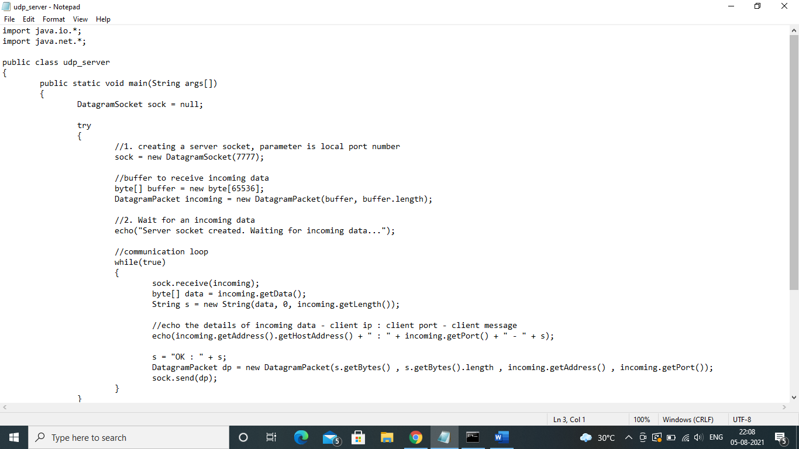

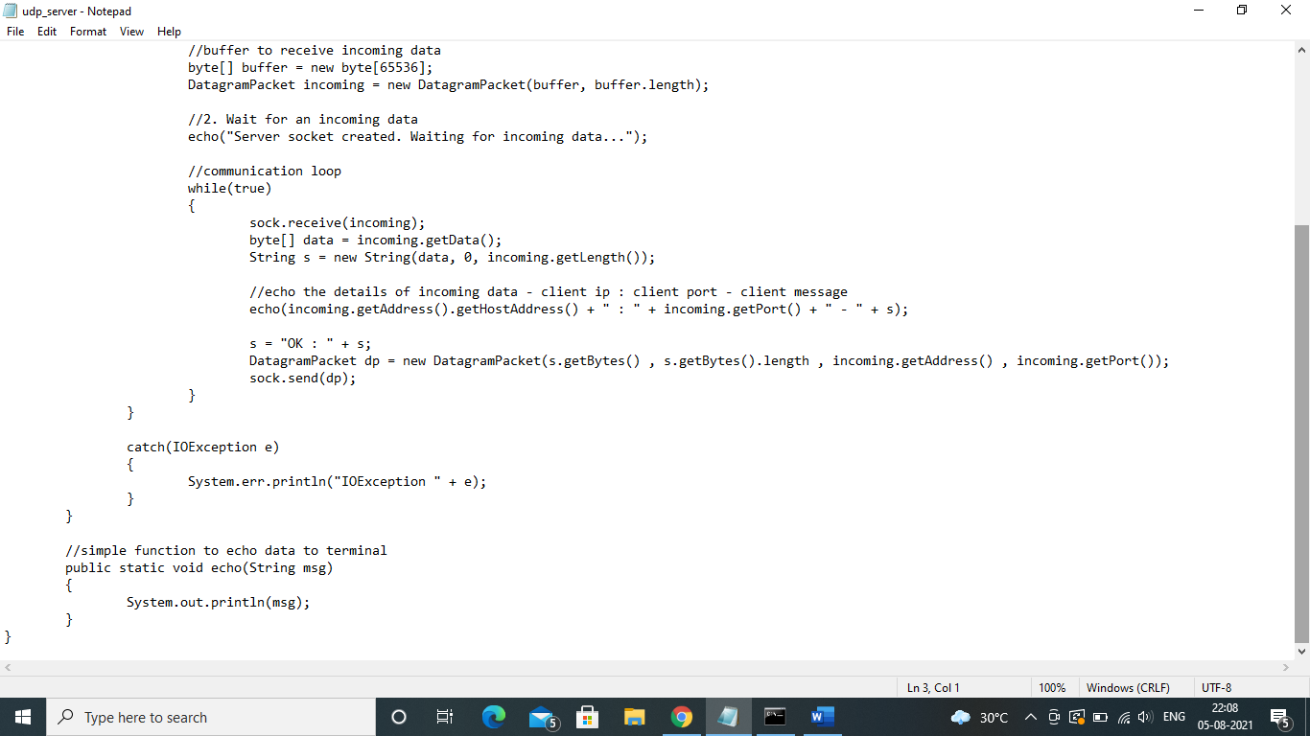

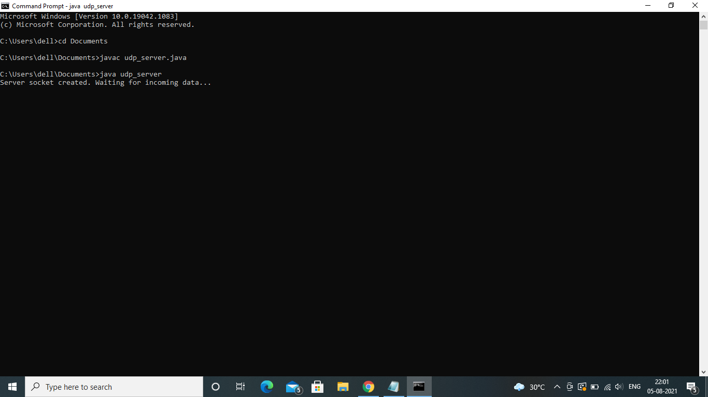

1. **Write a program to demonstrate status of key on Applet window such as KeyPressed, KeyReleased, KeyUp, KeyDown.**

import java.awt.*;

import java.awt.event.*;

public class KeyListenerExample extends Frame implements KeyListener{

Label l;

TextArea area;

KeyListenerExample(){

l=new Label();

l.setBounds(20,50,100,20);

area=new TextArea();

area.setBounds(20,80,300, 300);

area.addKeyListener(this);

add(l);add(area);

setSize(400,400);

setLayout(null);

setVisible(true);

}

public void keyPressed(KeyEvent e) {

l.setText("Key Pressed");

}

public void keyReleased(KeyEvent e) {

l.setText("Key Released");

}

public void keyTyped(KeyEvent e) {

l.setText("Key Typed");

}

public static void main(String[] args) {

new KeyListenerExample();

}

}

Output:

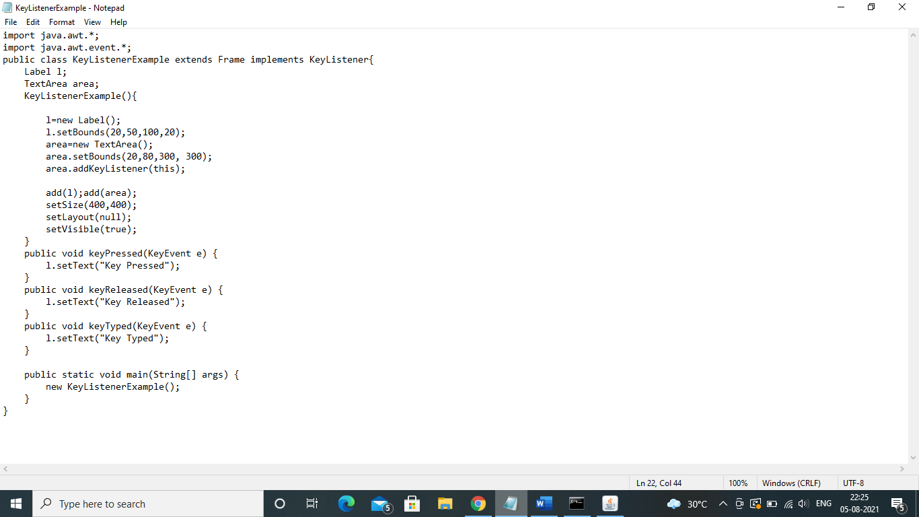

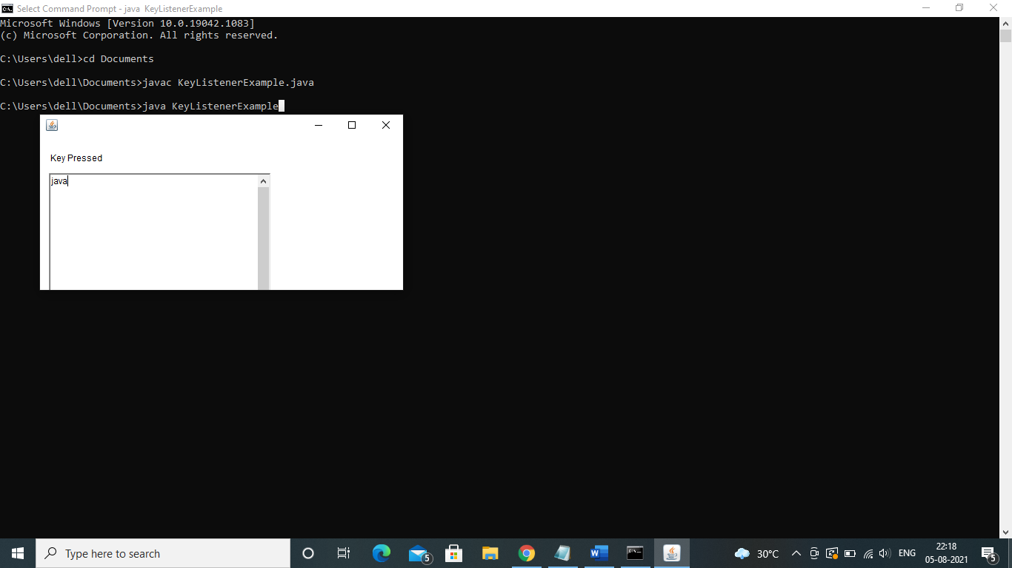

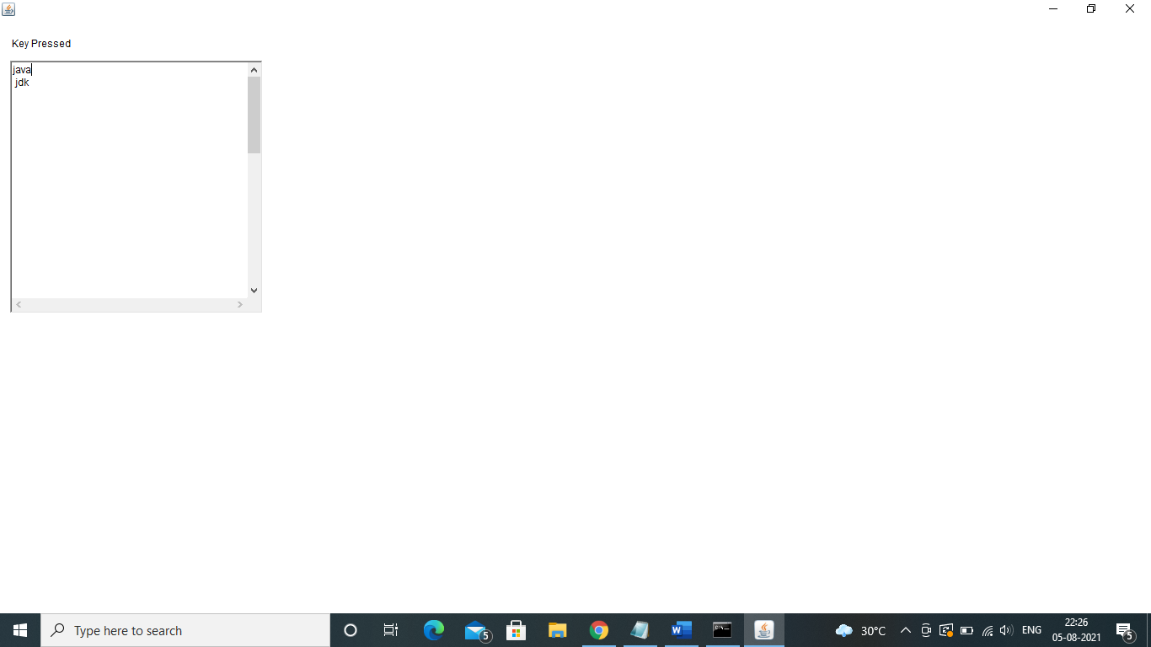

1. **Write a java program to create a file with your name, save it in the desktop, write some data on the file and then read and print that data into the console**

import java.io.*;

import java.io.IOException;

import java.util.*;

public class FileOrg {

public static void main(String[] args) {

try {

File myObj = new File("filename");

if (myObj.createNewFile())

{

System.out.println("File created with the name " + myObj.getName());

// To read the write content on the File............

FileWriter myWriter = new FileWriter("file name");

System.out.println("Enter Content");

Scanner input = new Scanner(System.in);

String str = input.nextLine();

myWriter.write(str);

myWriter.close();

// To show the output of the file.

System.out.println("The content of the files are as follows");

String line = null;

FileReader fileReader = new FileReader("file name");

BufferedReader bufferedReader = new BufferedReader(fileReader);

while((line = bufferedReader.readLine()) != null)

{

System.out.println(line);

}

bufferedReader.close();

}

else {

System.out.println("File already exists.");

}

}

catch (IOException e) {

System.out.println("An error occurred.");

e.printStackTrace();

}

}

}

Output:

